Exercise 3: Assertions in **JUNIT**

Solution:

Scenario: You need to use different assertions in JUnit to validate your test results.

Step: Write tests using various JUnit assertions.

Following is the run of test for assertions as directed in the scenario given in the practice handbook :

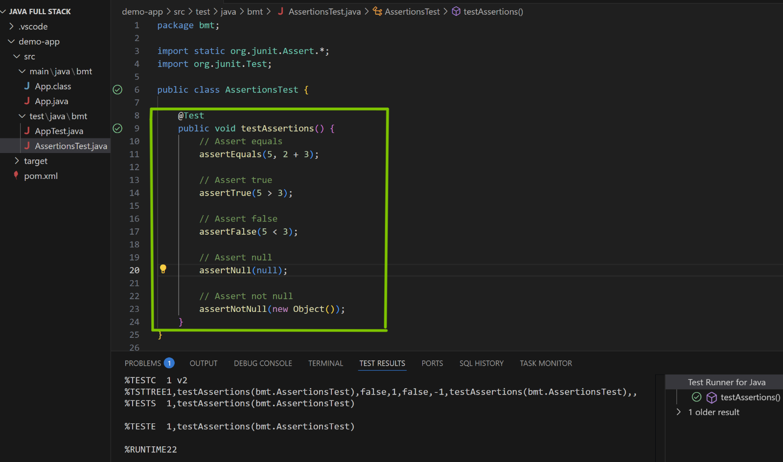

-The Green-tick in the screenshot pasted above demonstrates the successful run of the test-cases .

*********************************************************************************************